THE PETER FRAMPTON BAND’S INSTRUMENTAL COVERS ALBUM
FRAMPTON FORGETS THE WORDS
OUT NOW TO CRITICAL ACCLAIM
FEATURES INSTRUMENTALS OF SONGS BY
DAVID BOWIE, george harrison, RADIOHEAD, STEVIE WONDER, ROXY MUSIC, LENNY KRAVITZ AND MORE
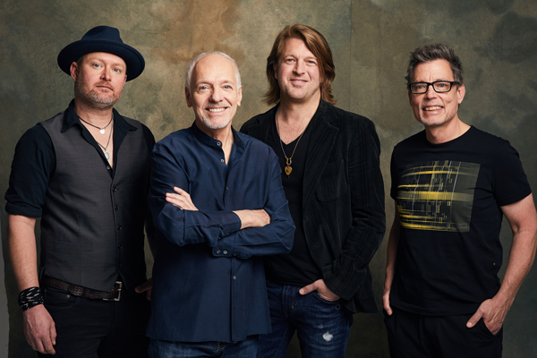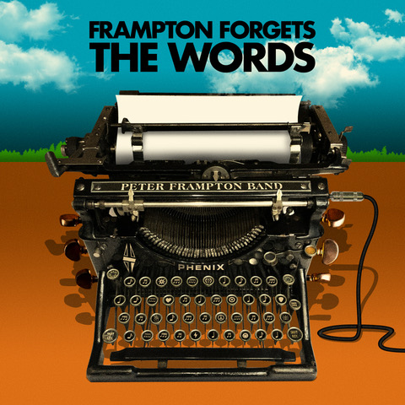
Photo credit Austin Lord Album artwork
April 23, 2021—Frampton Forgets the Words, the new studio album by The Peter Frampton Band, is out now via UMe. The album includes instrumental versions of some of Frampton’s favorite songs and is the follow up to his 2007 Grammy Award-winning instrumental album, Fingerprints. The new music is receiving widespread critical acclaim:
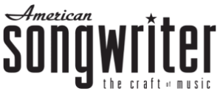
“These ten covers not only spotlight Frampton’s superb guitar prowess, but also prove how diverse his influences are.”

“…10 instrumental covers intended to remind us that Frampton
is one hell of a guitar player.”

“Frampton Forgets the Words is a grab-bag of 10 covers of rock songs that just plain move Frampton, and he imbues every lick and line of tunes by Radiohead (‘Reckoner’), Roxy Music (‘Avalon’) Lenny Kravitz (‘Are You Gonna Go My Way’) and other legacy artists with deep feeling and panache.”

“…he’s as firey as ever on the guitar.”
“Peter Frampton lets his guitar do the talking”
Frampton Forgets the Words is co-produced by Frampton and Chuck Ainlay and was recorded/mixed at Frampton’s own Studio Phenix in Nashville. With his storied 1954 Les Paul Phenix—which was lost in a plane crash in 1980 and recovered more than 30 years later—Frampton brings virtuosic guitar playing to songs including David Bowie’s “Loving The Alien,” George Harrison’s “Isn’t It A Pity,” Roxy Music’s “Avalon,” Radiohead’s “Reckoner,” and more.
Peter Frampton is among the most celebrated guitarists in rock history. At 18, he co-founded one of the first supergroups, Humble Pie. By 22, he was touring incessantly and making use of the talk box which would become his signature guitar effect. He’s collaborated with such legendary artists as George Harrison, David Bowie, Jerry Lee Lewis and Ringo Starr, among many others, and has toured with the likes of Stevie Nicks, Greg Allman, Lynyrd Skynyrd, Cheap Trick, and the Steve Miller Band. In 2014 he was inducted into the Musicians Hall of Fame.
His 2019 album All Blues (UMe), was #1 for fifteen weeks on Billboard’s Blues Chart, and his autobiography Do You Feel Like I Do?: A Memoir, released last October via Hachette Books, debuted on The New York Times Bestsellers list. His 1976 album, Frampton Comes Alive! remains one of the top-selling live records of all time and was inducted into the Grammy Hall of Fame last year.
FRAMPTON FORGETS THE WORDS TRACK LIST
1. If You Want Me To Stay
2. Reckoner
3. Dreamland
4. One More Heartache
5. Avalon
6. Isn’t It A Pity
7. I Don't Know Why
8. Are You Gonna Go My Way
9. Loving The Alien
10. Maybe

FIND PETER FRAMPTON ONLINE
Facebook | Website | Instagram | Spotify | Twitter
For more information please contact
Cami Operé or Carla Sacks at Sacks & Co., 212.741.1000,
cami.opere@sacksco.com or carla@sacksco.com.
Sujata Murthy or Tim Plumley at UMe
310.865.7812 | sujata.murthy@umusic.com
310.865.7797 | tim.plumley@umusic.com

