PETER FRAMPTON CONFIRMS
SPRING 2025 NORTH AMERICAN
“LET’S DO IT AGAIN!” TOUR
TICKETS ON-SALE FRIDAY
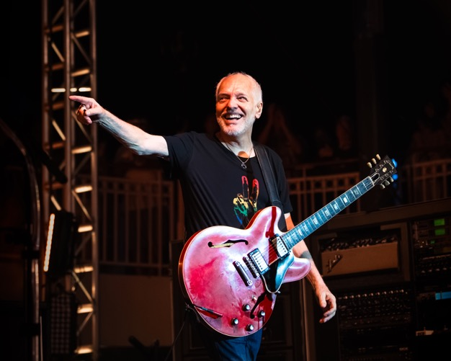
photo credit: Allison Morgan
January 21, 2025—Today, Rock & Roll Hall of Fame inductee and Grammy Award-winning guitarist, Peter Frampton, confirms the “Let’s Do It Again!” tour. Kicking off in late March, the dates include stops at Chicago’s Chicago Theatre, Milwaukee’s Riverside Theater, Port Chester’s Capitol Theatre and more.
“I am so thrilled to be able to come out and play again for you, it’s been a spectacular year, looking forward to seeing everyone soon.”
Tickets will be available at 10 A.M. local time on Friday, January 24 at peterframpton.com. See below for the complete tour itinerary.
The upcoming performances arrive on the heels of a landmark 2024 for the musician, who, in addition to being inducted into the Rock & Roll Hall of Fame, played concerts to rave reviews at venues across the U.S. Frampton’s “Never Say Never,” “Never EVER Say Never” and subsequent “Positively Thankful” tours were unexpected by fans after the legendary musician shared his diagnosis of the degenerative disease inclusion-body myositis.
“…the veteran singer-songwriter is finally getting his due on many levels.”—Ultimate Classic Rock
“Frampton’s musical journey is a testament to his unparalleled talent and versatility, and last night its culmination was on full display.”—Relix
“Despite the medical setbacks he’s faced in recent years, it’s obvious that Frampton still has a lot of fight left in him and that he’s not ready to hang up his guitar just yet.”—Creative Loafing
“[Frampton] and his four-piece backing band were subject to adulation (and standing ovations) the whole night. No one in the room let up.”—Cleveland Plain Dealer
“It was a performance that left no soul untouched.”—Grateful Web
“Iconic Brit shows us the way to keep playing with grace, humor, and some damn fine music.”
—Santa Barbara Independent
Peter Frampton is one of the most celebrated artists and guitarists in rock history. In 2007, Frampton won a Grammy for Best Pop Instrumental Album for Fingerprints and in 2014 was inducted into the Musicians Hall of Fame. He received the prestigious Les Paul Innovation Award at NAMM’s TEC Awards in 2019 and most recently received the 2024 Les Paul Spirit Award at the Gibson Garage Nashville. Last fall, the iconic guitarist was inducted into the Rock & Roll Hall of Fame in Cleveland.
In 2020, Frampton was inducted into the Grammy Hall of Fame, his autobiography, Do You Feel Like I Do?: A Memoir, debuted on The New York Times Bestsellers list and he appeared on Dolly Parton’s latest album, Rockstar, as the only artist featured on two tracks.
In 2023, Frampton unveiled Frampton@50 on Intervention Records, a numbered limited-edition vinyl box set featuring Frampton’s essential 1972-1975 studio releases Wind of Change, Frampton’s Camel and Frampton. He also received The Myositis Association’s Heroes in the Fight 2023 Patient Ambassador Award and unveiled his historic performance at London’s Royal Albert Hall as a live album via UMe—listen here.
After nearly 50 years, Frampton Comes Alive! remains one of the top-selling live records of all time, selling over 17 million worldwide.
PETER FRAMPTON LIVE
March 30—Uncasville, CT—Mohegan Sun Arena
April 1—Port Chester, NY—The Capitol Theatre
April 3—Bethlehem, PA—Wind Creek Event Center
April 5—Atlantic City, NJ—Hard Rock Hotel & Casino Atlantic City - Hard Rock Live at Etess Arena
April 7—New Brunswick, NJ—State Theatre New Jersey
April 9—Niagara Falls, ON—OLG Stage at Fallsview Casino
April 11—Carmel, IN—The Center for the Performing Arts - The Palladium
April 15—Milwaukee, WI—The Riverside Theater
April 17—Chicago, IL—The Chicago Theatre
April 19—Mount Pleasant, MI—Soaring Eagle Casino & Resort – Outdoor Summer Concert Series
FIND PETER FRAMPTON ONLINE
Facebook | Website | Instagram | Spotify | Twitter
For more information, please contact
Krista Williams or Carla Sacks at Sacks & Co., 212.741.1000,
krista@sacksco.com or carla@sacksco.com

