FRAMPTON@50 LIMITED EDITION VINYL BOX SET COMING JULY 28
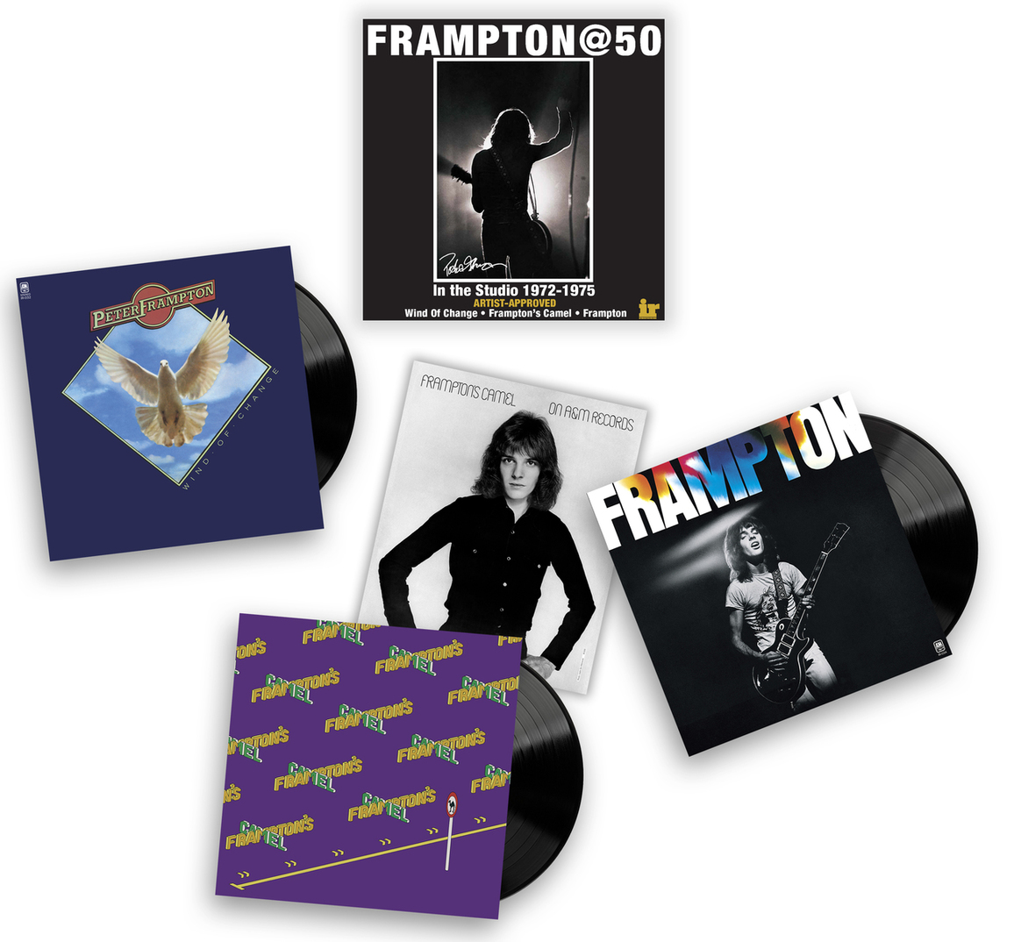
March 21, 2023—Grammy Award-winning guitarist Peter Frampton is releasing Frampton@50, a limited-edition vinyl box set, via Intervention Records. The exclusive set is limited to just 2,500 copies and will be shipped July 28. Pre-order available HERE.
Frampton@50 is comprised of meticulously restored 180G reissues of Frampton’s essential 1972-1975 studio releases Wind of Change, Frampton’s Camel and Frampton. The numbered limited box set also comes with an authentic reproduction of the promo poster that was only included in the earliest original LP copies of Frampton’s Camel and a Certificate of Authenticity with a message from Frampton.
In addition, the Peter Frampton webstore has 250 sets that include an autographed version of the Frampton’s Camel promo poster, with the proceeds benefitting the Peter Frampton Myositis Research Fund. Pre-order for the autographed charity version is available HERE.
Intervention approached the Frampton@50 album art restoration with the same fanatical attention to detail and authenticity as the audio. The jackets for all three Frampton@50 Series LPs are Old Style “Tip Ons” by Stoughton Printing, with Wind of Change and Frampton’s Camel sporting “brown-in” blanks true to the UK original LP releases. Frampton original LPs came with an inner sleeve with lyrics printed on both sides, which Intervention has expanded to comprise the interior panels of a gorgeous single-LP gatefold. All three LP jackets are printed on heavy stock, and film laminated for enhanced beauty and durability.
The box is a deluxe slip case, with a matte-textured finish and spot Gloss UV highlighting the main image, and double-pass foil numbering.
The Frampton@50 Series studio releases are also available for pre-order now on hybrid CD/SACDs which play on all CD and SACD players. These CD/SACDs feature the same definitive remastered audio as the 180G LPs, mastered by Chris Bellman at Bernie Grundman Mastering Direct-to-DSD from analog tapes. These will ship in April 2023.
FIND PETER FRAMPTON ONLINE
Facebook | Website | Instagram | Spotify | Twitter
For more information please contact
Cami Operé or Carla Sacks at Sacks & Co., 212.741.1000,
cami.opere@sacksco.com or carla@sacksco.com.
Or Shane Buettner shane@interventionrecords.com at Intervention Records.

